# Denmark Senior High School

# Year 12 Mathematical Methods Investigation 2 Semester 1 2017

# Name Due

You will have one week in which to complete this investigation. “Answer only" solutions will be provided so it will be up to you to seek help early if required. On the due date hand in your completed investigation and be prepared for a short test based on similar material. You will not be able to have any written notes during the validation. You will not be able to have the investigation with you during the validation.

**BINOMIAL DISTRIBUTION**

• An event (or trial) is repeated `n' times

• There are only two outcomes to a trial: A, A'

• The probability of A occurring is known

**Part A: The Coin**

A coin has been damaged and is not flat. The probability that it comes up `heads' on a single toss is currently unknown, but can be designated as `p'.

1. The probability that this coin will not come up heads on a single toss is

1 – p. Explain why this must be so.

Despite the fact that the coin is damaged, it still has only two outcomes from a single toss (trial): a head or a tail.

A probability tree diagram of two trials of this coin is:



1. Explain why the branches and probabilities appear as they do.
2. Use the tree diagram to list the probabilities of two trials with this coin.

eg P( HH ) = p.p = p2 )

**Part B: More Coins**

1. Draw a tree diagram showing three trials with this coin, and list the probabilities when the probability of getting a `head' is `p'.

2. Copy and complete this table using the list of probabilities.

|  |  |  |
| --- | --- | --- |
| Number of Heads | Number of times this occurs | Total Probability |
| 0 |  |  |
| 1 |  |  |
| 2 |  |  |
| 3 |  |  |

3. Complete the following:

3C0 = _____ 3C1 = _____ 3C2 = _____ 3C3 = _____

4. Use your findings in this section to explain an equation which states that:

P(X = 2) = 3C2 p2 ( l - p)

5. i) Give a similar equation to describe the probability of two heads if

this coin was tossed 4 times.

ii) Draw a probability tree diagram to test your equation.



**Part C: Assigning a Probability**

1. If the probability that the damaged coin comes up `heads' in a single toss is

, determine the probability that, if this coin is tossed three times, the result will be:

i) 0 heads ii) 1 head iii) 2 heads iv) 3 heads

v) at least one head vi) no more than one head

2. Determine the sum of the probabilities in parts i) to iv) above.

Comment on this result.

**Part D: Beer! j0228873**

A brewery produces a very popular brand of lager. To expand its market, it wishes to introduce an ale. It is important that the ale tastes different to the lager.

In a triangle test, a taster is asked to sample each of three similar-looking glasses of beer, two of which are lager and one of which is ale.

1. If the taster guesses:

i) what is the probability that he identifies the ale correctly,

ii) what is the probability that he does not identify the ale correctly?

He does the triangle test three times. A success is identifying the ale correctly.

2. Copy and complete this table to find the probability of success given he is guessing.

|  |  |  |
| --- | --- | --- |
| Number of Successes | Probability Calculation | Probability |
| 0 |  |  |
| 1 |  |  |
| 2 |  |  |
| 3 |  |  |

3. What is the probability that he identified the ale correctly when guessing:

1. twice
2. at most twice

iii) at least once

**Part E: Patients**

Twenty percent of patients brought to a hospital by ambulance should be admitted to the intensive care ward. On a particular night, the ward has six spare beds, and fifteen people were brought to the hospital by ambulance.

A success (X), is defined as "the number of patients who should be admitted to the intensive care ward".

1. What is the number of trials (n) in this problem?

2. What is the probability of success in this problem?

3. What is P(X = 4) asking you to find?

4. Find P(X = 4).

5. Find the probability that the hospital would need to turn one patient away from the intensive care ward.



# 12 MAM Investigation 2 Validation Test Semester 1 2017

# Name

Time: 25 minutes

Graphic calculators allowed. Test /25

**BINOMIAL DISTRIBUTION**

**No notes of any kind allowed during the test.**

1. [1 mark]

In an experiment consisting of **n** trials with **p** chance of success in each trial, write down an expression for the probability of **x** successes.

2. [5 marks]

An unfair coin, where P(head) = 0·4, is tossed four times.

a) Complete this Probability Table of P(X = x), where

X = the number of heads.

|  |  |  |  |  |  |
| --- | --- | --- | --- | --- | --- |
| x | 0 | 1 | 2 | 3 | 4 |
| P(X = x) |  |  |  |  |  |

b) Determine the probability that

1. at least one head occurred.

ii) at most two heads occur.

3. [6 marks]

A six-sided die is tampered with, so that the probability of rolling a six is 0·3.

If the die is rolled five times, find the probability of

a) two sixes.

b) no sixes.

c) at least three sixes.

d) no more than 4 sixes.

4. [7 marks]

On a particular turtle sanctuary, 25% of all turtles survive for six weeks after hatching. 35 turtles hatch on the same day and are tagged for study.

1. Find the probability that:
2. All 35 turtles survive the six weeks.
3. None of the turtles survive the six weeks. (no need to evaluate)
4. Write down expressions for the probability that:
5. No more than 2 turtles out of the 35 will survive the six weeks.
6. More than 2 turtles out of the 35 will survive the six weeks.

5. [6 marks]

A BBQ lighter ignites on any one trial with a probability of 0·4. The BBQ lighter will be tried until it ignites, if at all. You wish to be at least 99% sure that it will ignite.

1. What is the minimum number of trials you should allow?
2. The BBQ lighter has enough fuel to ignite 9 times. Calculate the probability that the lighter will use the last of its fuel on the eleventh trial.
3. The BBQ lighter is disposable. If it fails to ignite 8 times in a row, it is thrown away. Calculate the probability that it will be thrown away for this reason before the eleventh trial.

# 12 MAM Investigation 2 Validation Test Semester 1 2016

# Name SOLUTIONS

Time: 25 minutes

Graphic calculators allowed. Test /25

**BINOMIAL DISTRIBUTION**

**No notes of any kind allowed during the test.**

1. [1 mark]

In an experiment consisting of **n** trials with **p** chance of success in each trial, write down an expression for the probability of **x** successes.

P(X = x) = nCx . px . (1 – p)n – x 🗸

=

2. [5 marks]

An unfair coin, where P(head) = 0·4, is tossed four times.

a) Complete this Probability Table of P(X = x), where

X = the number of heads.

|  |  |  |  |  |  |
| --- | --- | --- | --- | --- | --- |
| x | 0 | 1 | 2 | 3 | 4 |
| P(X = x) | 0·1296 | 0·3456 | 0·3456 | 0·1536 | 0·0256 |

🗸🗸🗸

0 – 1 per error

b) Determine the probability that

1. at least one head occurred.

0·3456 + 0·3456 + 0·1536 + 0·0256 = 0·8704 🗸

(or 1 – 0·1296 = 0·8704 )

ii) at most two heads occur.

0·1296 + 0·3456 + 0·3456 = 0·8208 🗸

(or 1 – 0·1536 – 0·0256 = 0·8208 )

3. [6 marks]

A six-sided die is tampered with, so that the probability of rolling a six is 0·3.

If the die is rolled five times, find the probability of

a) two sixes.

P(X = 2) = 5C2 (0·3)2 (0·7)3

= (0·3)2 (0·7)3

= 0·3087 🗸

b) no sixes.

P(X = 0) = 5C0 (0·3)0 (0·7)5

= 0·16807 🗸

c) at least three sixes.

P(X ≥ 3) = P(X = 3) + P(X = 4) + P(X = 5)

= 0·1323 + 0·02835 + 0·00243

= 0·16308 🗸🗸

d) no more than 4 sixes.

P(X ≤ 4) = 1 – P(X = 5)

= 1 – 0·00243

= 0·99757 🗸🗸

4. [7 marks]

On a particular turtle sanctuary, 25% of all turtles survive for six weeks after hatching. 35 turtles hatch on the same day and are tagged for study.

a) Find the probability that:

1. All 35 turtles survive the six weeks.

0·2535 = 0 🗸

1. None of the turtles survive the six weeks. (no need to evaluate)

(1 – 0·25)35 = 0·7535 = 0·0000424 🗸

b) Write down expressions for the probability that:

1. No more than 2 turtles out of the 35 will survive the six weeks.

X ~ Bin(35,0·25) 🗸

P(X ≤ 2) = P(X = 0) + P(X = 1) + P(X = 2) 🗸

= 35C0(0·25)0(0·75)35 + 35C1(0·25)1(0·75)34 + 35C2(0·25)2(0·75)33 🗸

1. More than 2 turtles out of the 35 will survive the six weeks.

P(X > 2) = 1 – [P(X = 0) + P(X = 1) + P(X = 2)] 🗸

= 1 – [35C0(0·25)0(0·75)35 + 35C1(0·25)1(0·75)34 + 35C2(0·25)2(0·75)33]

🗸

5. [6 marks]

A BBQ lighter ignites on any one trial with a probability of 0·4. The BBQ lighter will be tried until it ignites, if at all. You wish to be at least 99% sure that it will ignite.

a) What is the minimum number of trials you should allow?

1 – 0·6n ≥ 0.99 🗸

Solve for n n ≥ 9·0152

∴ n = 10 trials 🗸

b) The BBQ lighter has enough fuel to ignite 9 times. Calculate the probability that the lighter will use the last of its fuel on the eleventh trial.

P(ignites on 11th ) × P( ignites on 8 of 10 before) 🗸

= 0·4 × 10C8(0·4)8(0·6)2

= 0·4 × (0·4)8 (0·6)2

= 0·4 × 0·0106

= 0·00424 🗸

c) The BBQ lighter is disposable. If it fails to ignite 8 times in a row, it is thrown away. Calculate the probability that it will be thrown away for this reason before the eleventh trial.

If it fails 8 times in a row to be thrown away then it must have ignited on 0, 1 or 2 at the beginning for it to be thrown away on the 11th trial.

(0·4)0(0·6)8 + (0·4)1(0·6)8 + (0·4)2(0·6)8 🗸

= 0·0262 🗸

12 MAM Investigation 2 Semester 1 2016

ANSWER ONLY SOLUTIONS **BINOMIAL DISTRIBUTION**

PART A: THE COIN PART D: BEER

1. sum of probability = 1 1. i) P(ALE) =

2. explain tree diagram

3. P(HH) = p2 ii) P(not ALE) =

P(HT) = p(1 – p), etc

2. 0 3C0

PART B: MORE COINS

1

1. tree diagram

P(HHT) = p2(1 – p) 2

P(THT) = p(1 – p)2, etc

2. 0 1 p3 3

1 3 3p(1 – p)2

2 3 3p2(1 – p) 3. i)

3 1 (1 – p)3

3. 1 ii)

3

3 iii)

1

4. explanation

5. i) 4C2 p2 (1 – p)2 PART E: PATIENTS

ii) tree diagram

include list of outcomes 1. 15

P(HHHH), etc 2. 0·2

Include all of p4 3. 4 people admitted to intensive

p3(1 – p), etc care

4. 0·1876 (4dp)

PART C: ASSIGNING PROBABILITY 5. 0·0138 (4dp)

1. P(H) = 0·8

P(not H) = 0·2

i) 0·008

ii) 0·096

iii) 0·384

iv) 0·512

v) 0·992

vi) 0·104

2. 1

12 MAM Investigation 2 Semester 1 2016

WORKED SOLUTIONS **BINOMIAL DISTRIBUTION**

PART A: THE COIN

1. The total of all probability of a trial is equal to one. It the probability of an event occurring is ‘p’, then the probability of the event not occurring is ‘1 – p’.

ie the sum of all the other events in the trial. p + (1 – p) = 1

2. The first branch represents the first trial which has two possible outcomes, a head or a tail. If the first trial results in a head, the second trial also has two possible outcomes, a head or a tail as it is independent of the first trial. This results in a second set of branches. Similarly, if the first trial results in a tail instead of a head, the second trial is independent of the first and results in either a head or a tail. If the probability of a head is ‘p’ then the probability of a tail must be ‘1 – p’.

3. P(HH) = pp = p2

P(HT) = p(1 – p)

P(TH) = (1 – p)p = p(1 – p)

P(TT) = (1 – p)(1 – p) = (1 – p)2

PART B: MORE COINS

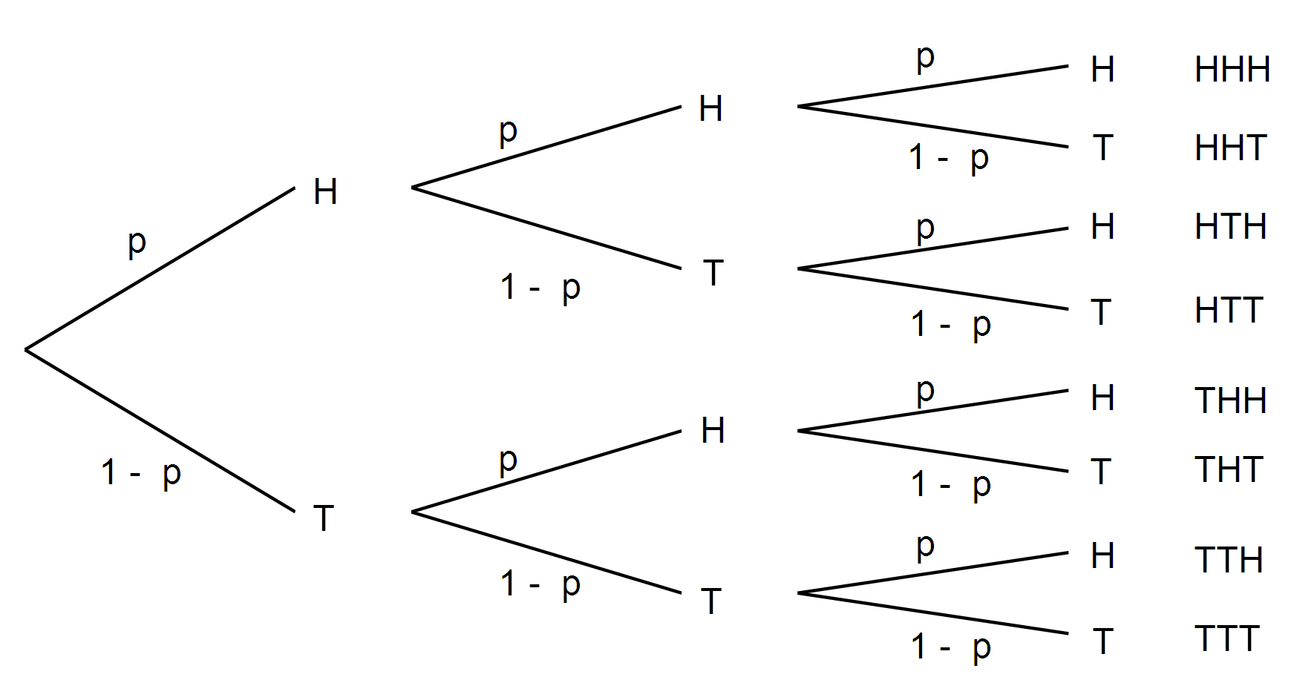1.

Probabilities for outcomes are as follows:

p3

p2(1 – p)

p2(1 – p)

p(1 – p)2

p2(1 – p)

p(1 – p)2

p(1 – p)2

(1 – p)3

2.

|  |  |  |
| --- | --- | --- |
| Number of heads | Frequency | Total probability |
| 0 | 1 | p3 |
| 1 | 3 | 3 p(1 – p)2 |
| 2 | 3 | 3 p2(1 – p) |
| 3 | 1 | (1 – p)3 |

3. 3C0 = 1 3C1 = 3 3C2 = 3 3C3 = 1

4. P(X = 2) = 3C2 p2(1 – p)

P(X = 2) means: find the probability of an outcome that has two heads

3C2 means: out of the possible outcomes of three trials, this is the

number which will contain two heads

p2(1 – p) means: the outcomes in question will contain 2 heads and a tail. The probability of two heads and one tail occurring will be

P(H) × P(H) × P(T) = p.p.(1 – p) = p2(1 – p)

∴ P(X = 2) = 3C2 p2(1 – p) means: to find the probability of two heads occurring you must find the number of possible combinations of 2 heads and 1 tail, and multiply this by the probability of this event.

5. i) P(X = 2) = 4C2 p2(1 – p)2

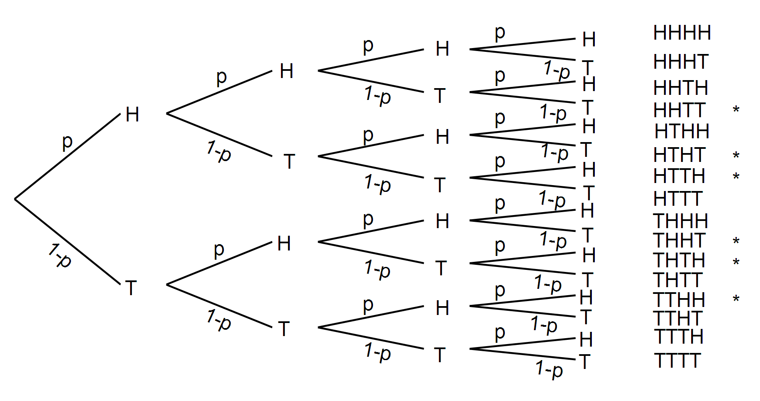 ii)

* 6 outcomes contain 2 heads 4C2 = 6

4 trials resulting in 2 heads and 2 tails will have a probability of p2(1 – p)2

∴ P(X = 2) = 4C2 p2(1 – p)2

PART C: ASSIGNING PROBABILITY

1. P(H) = = 0·8 ∴ P() = 1 – = = 0·2

i) P(X = 0) = 3C0 (0·8)0 (0·2)3 = 0·008

ii) P(X = 1) = 3C1 (0·8)1 (0·2)2 = 0·096

iii) P(X = 2) = 3C2 (0·8)2 (0·2)1 = 0·384

iv P(X = 3) = 3C3 (0·8)3 (0·2)0 = 0·512

v) P(X ≥ 1) = 0·096 + 0·384 + 0·512 = 0·992

vi) P(X ≤ 1) = 0·008 + 0·096 = 0·104

2. P(X = 0) + P(X = 1) + P(X = 2) + P(X = 3)

= P(no heads) + P(one head) + P(2 heads) + P(3 heads)

= 0·008 + 0·096 + 0·384 + 0·512

= 1

Probability of no heads, one head, two heads, three heads represent all the possible outcomes. ∴ sum = 1

PART D: BEER

1. i) Only one glass of the three contain ale ∴ P(ale) = $\frac{1}{3}$

ii) P($\overline{ale}$) = $\frac{2}{3}$

2.

|  |  |  |
| --- | --- | --- |
| Number of successes | Calculation | Probability |
| 0 | 3C0 |  |
| 1 | 3C1 |  |
| 2 | 3C2 |  |
| 3 | 3C3 |  |

3. i) P(X = 2) =

ii) P(X ≤ 2) = + + =

iii) P(X ≥ 1) = $0∙\overline{4}$ + $0∙\overline{2}$ + $0∙\overline{037}$ = $0∙\overline{703}$

PART E: PATIENTS

1. 15 patients. Each patient represents a trial. ∴ n = 15 trials

2. Probability of success means admission to intensive care ward.

p = 20% = 0·2

3. P(X = 4) means find the probability that 4 people were admitted to the intensive care ward.

4. P(X = 4) = 15C4(0·2)4(0·8)11 = 0·1876 (4dp)

5. If 6 beds are available and 1 person was turned away, then 7 people needed to be admitted to the intensive care ward.

P(X = 7) = 15C7(0·2)7(0·8)8 = 0·0138 (4dp)